# Public Notice

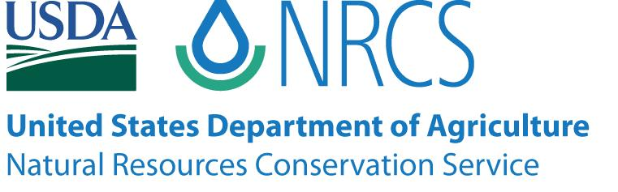

Columbia County Natural Resources Conservation Service (NRCS) Local Work Group Meeting

**When:** February 16, 2023

**Time:** 9:30 a.m. – 12:30 p.m.

**Hybrid Location:**

USDA Service Center

35285 Millard Road, St. Helens

Or Virtual Zoom online Meeting

Please contact Hannah Isaacs at [hannah.isaacs@usda.gov](mailto:hannah.isaacs@usda.gov)

for Zoom passcode and login information

The purpose of the meeting is to receive public input from farmers, ranchers, foresters, agencies, and groups to help guide the conservation efforts of the Natural Resources Conservation Service in Columbia County. Due to COVID concerns, our meeting will be offered both in-person at the office and virtual via Zoom online for those that wish to join that way.

For questions or persons with disabilities who require accommodations to participate in this meeting, please contact Hannah Isaacs with the USDA-NRCS at (503) 438-3146 by February 9, 2023, or dial 7-1-1 to access telecommunication relay services.

*The USDA is an equal opportunity provider, employer, and lender.*